Welcome
Alfa Tech India develops and manufactures Milking and Dairy Machines. With an experience of over 30 years in the field of Dairy and Agriculture, the name 'Alfa Tech India' has become a brand of Quality and Trust.

About Us
Founded in 1990 by Mr. Milind Bhandarkar; Alfa Tech India has become a brand of Quality and Trust.
We combine our technology & strengths with those of our principles to provide solutions at cutting edge of technology of today’s Indian dairy industry.
The quality preservation begins with Alfa Tech India. We customize product development, sturdy range, best quality, reasonable price & easy to operate instruments are appreciated nationally. We are quick with large volumes.
Our experience in this field is our guarantee to you. By applying up-to-date technology, this standard will also be maintained in the future.
Quality is the heart of the product & this is attained by means of very thorough quality control during the entire production process.
Today we promise absolute, reliable, customized & hardworking equipment, which is backed by professionally trained engineering support with ensuring least down time for any critical problem.

Certification:
- The Alfa Tech India is only Quality Approved Vendor of NDBB (National Dairy Development Board is under central ministry of India which implement QPM (Quality Milk Program)
- The company was conferred the status of ‘MINIRATNA’ by the Department of Public Enterprise Ministry of Industry Govt. of India, on the basis of excellent performance & quality product.

Our strength Is In
- Strong in-house R & D capability.
- Ability to supply large quantity in short span.
- Tested technology , leveraging , accumulated experience industry.
- Manufactured to international standards, adapted to tropical conditions.
- Special manufacturing technique ensures longer operational durability with all respects & gives it longer life with lower maintenance cost.
- More than 100,000 satisfied customers.
- Quality milk collection improves the Fat, SNF, CLR, at grass root milk collection.
Contact Us:
E-mail: sales@alfatechindia.com
Phone: +919822020999; +919850584191

Clients
No. | Name | Town
1 | Sahyadri Agro Produce & Dairy Products | Baramati
2 | Schreiber Dynamix dairies Ltd | Baramati
3 | Mahananda Dairy | Mumbai
4 | VRS Food & Milk Products | Lucknow
5 | Dwaraka Dudh | Vashi
6 | Heritage food | Hyderabad
7 | Filtron Engineer | Pune
8 | Karnataka Milk federation All Dairies | Karnataka
9 | Government Milk Schemes All Daires | Maharashtra
10 | Shivamrut Dudh Utp Saha. Sangh Ltd | Akluj
11 | Amrutsagar Saha Dudh Utp Sangh | Akole
12 | Manjara Dudh Sangh | Latur
13 | Solhapur Zilla Dudh Upt Sangh | Solapur
14 | Latur Dist Dudh Utp Sangh | Latur
15 | Jijamata Tq. dudh sangh | Deyulgaon raja
16 | Samarth dudh utp Sangh | Ambad
17 | Akola Dist Dudh Utp Saha. Sansth | Akola
18 | Pune Dist Saha. Dudh Sangh, Katraj | Pune
19 | Aurangaabad Dist Saha.Dudh Sangh | Aurangabad
20 | Hutatma Saha. Dudh Utp Sangh, walva | Sangli
21 | Bhoom Tq. Saha. Dudh Sangh | Bhoom
22 | Beed Tq. Dudh Utp Sangh | Beed
23 | Potada Tq. Dudh Utp Sangh | Patoda
24 | Godavari Khore Saha. Dudh Utp Sangh | Kopergaon
25 | Chandrabagh saha.sangh | Beed
26 | Sangamner Tq.saha.Dudh Utp.Sangh | Sangamner
27 | Rajarambapu Patil saha. Dudh Sangh | Islampur
28 | Srigonda Tq. Saha.dudh utp. Sangh | Srigonda
29 | Phaltan Tq. Saha. Dudh sangh | Phaltan
30 | Parag Milk | Manchar
31 | Govind Mik | Phaltan
32 | Gowardhan Milk | Manchar
33 | Phattesingh Naik saha. Dudh Sangh | Shirala
34 | Bhandara Dist. Dudh utp. Saha.sangh | Bhandara
35 | Tulzabhavani dist.saha.utp.sangh | Osmanabad
36 | Srirampur Dudh zilla.saha.sangh | Babhaleshwar
37 | Shree warna Saha.Dudh Sangh | warna nagar
38 | Sinner Tq. Dudh sangh | Sinner
39 | Siddarth milk & milk products | Ichhalkarnji
40 | Shree Warna sah. Dudh utp. Sangh ltd | Kolhapur
41 | Kolhapur Zillha Dudh Sangh ltd - Gokul | Kolhapur
42 | Sangamner taluka sah . dudh sangh | Sangamner
43 | Satara Zilla sah. Dudh utp. Sangh ltd | Satara
44 | Vasantdada Sah.dudh utp. Sangh ltd | Tasgaon
45 | Solapur zilla sah . dudh utp. Sangh ltd | Solapur
46 | Sawabhimai Milk & Milk Products Ltd | Jayshingpur
47 | Belgaum dist co. Op. Milk union Ltd | Belgaum
48 | Sayhadri sahkari dudh utp. Sangh | Kolhapur
49 | Milkline Dairy Products Pvt Ltd | Hyderabad
and all the other thousand satisfied farmers all over the country...& world too…
Contact Us:

Milking Machine

Features
- Milking time for an animal 4 to 5 min.
- Works for Cows and Buffaloes.
- Works on Electricity, Kerosene, Petrol or Diesel and Inverter.
- Automatic cut 'off' after milking.
- No any harmful for the animal(Blood & infection).
- Easy to use and install, Saves Time & Labour Charges.

Configurations
- Mini Milking Machine: For upto 5 cows per hour.
- Single Bucket Milking Machine: For upto 15 Cows and 10 Buffaloes per hour.
- Double Bucket Milking Machine: For up to 30 cows and 25 buffaloes per hour.
- Multi-Bucket Milking Machine & Parlour: More than 50 Cows or Buffaloes per hour.

Technical Specifications
- 0.25/0.5/1 HP single phase Godrej Motor
- Vacuum Pump: 200/400 lpm
- Bucket: 20ltr S.S 304
- Orbiter: 300cc
- Pulsator: 60/40 pulsation ratio
- Brush set
- Accessories
- 1.5HP Honda Engine (optional)
I will give 2 new photos of Milking machines

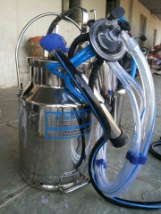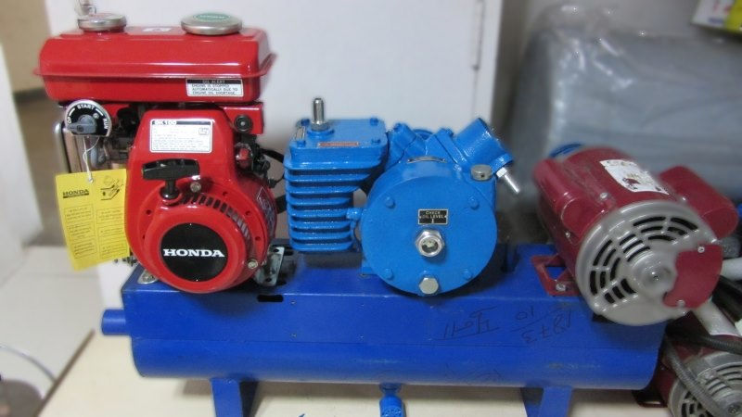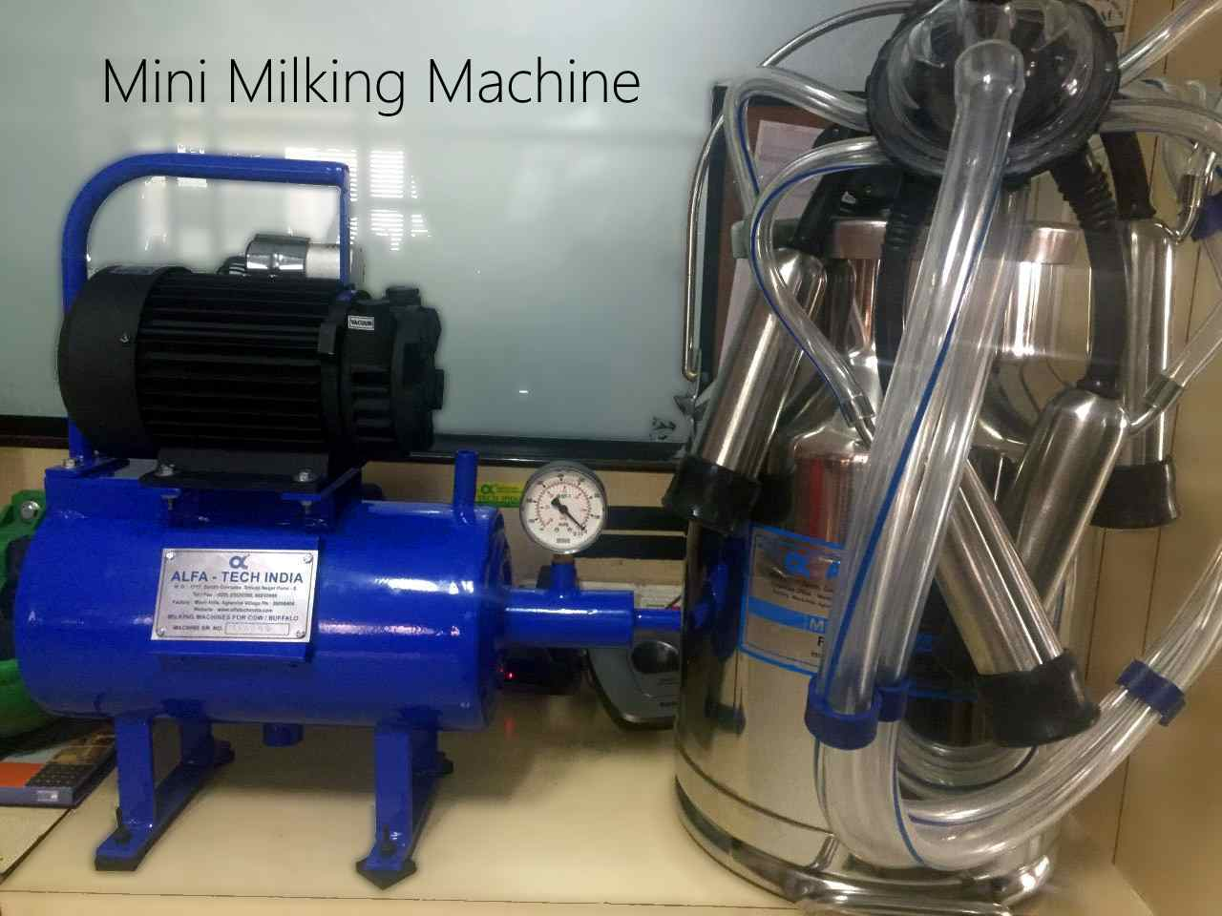
get quote
get quote

Demonstration of Alfa Tech India Milking Machine

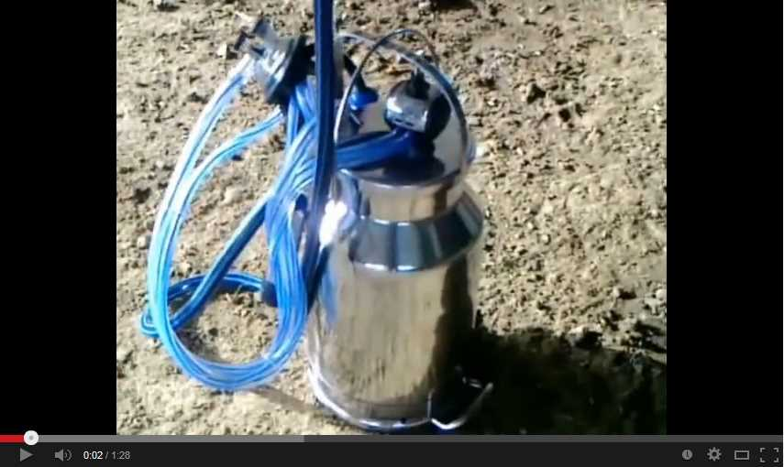

Khawa (mawa) Machine
get quote
Works on Gas, Diesel and Wood
65 Liter Capacity Weight : 155 Kgs.
- Motor : ½ HP
- Capacity : Min. 3 Ltrs. Max 20Ltrs. to procure khawa (Mawa) from 10 Lit Milk in 50 min. & Gas consumption 0.8 K.G.
130 Liter Capacity Weight : 185 Kgs.
- Motor : ½ HP
- Capacity : Min. 5 Ltrs. Max 40Ltrs. to procure khawa (Mawa) from 20 Lit Milk in 50 min. & Gas consumption 1.5 K.G.
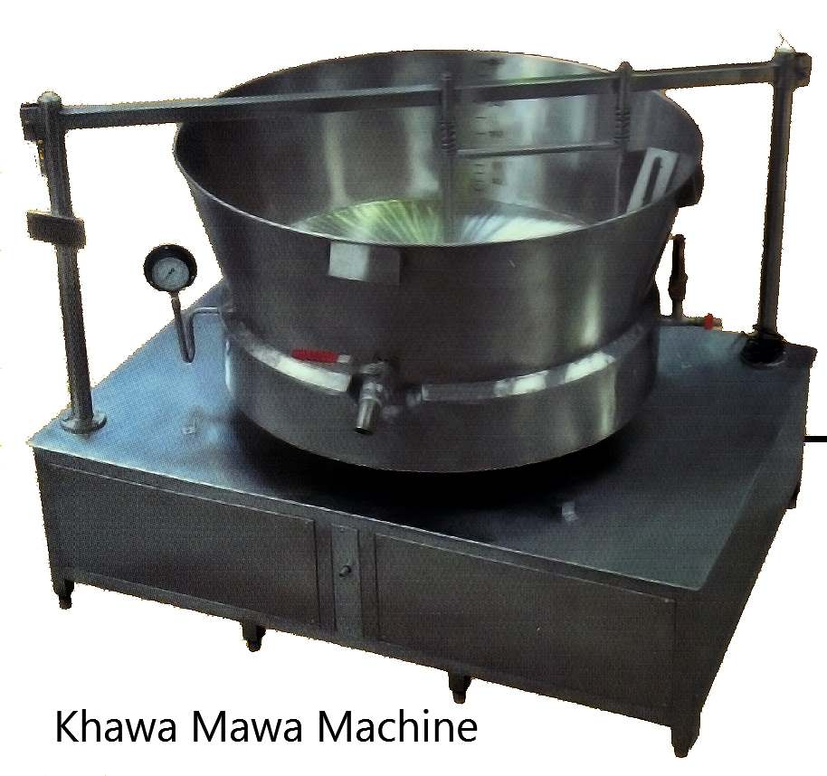

Electric Centrifugal Cream Separator
get quote
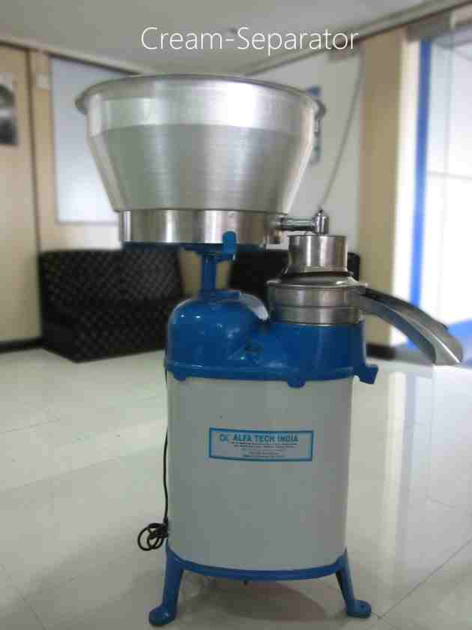
300 Liter per hour Capacity
- Motor : ½ HP Single Phase
- Tank Capacity : 100ltr
- Body: S.S 304 or Mild Steel
- Stainless Steel Bowl and Bowl Disc
- Steel Spout Set & Stainless Steel Receiving Tank
500 Liter per hour Capacity
- Motor : ½ HP Single Phase
- Tank Capacity : 150ltr
- Body: S.S 304 or Mild Steel
- Stainless Steel Bowl and Bowl Disc
- Steel Spout Set & Stainless Steel Receiving Tank

Lactoscan and EkoMilk
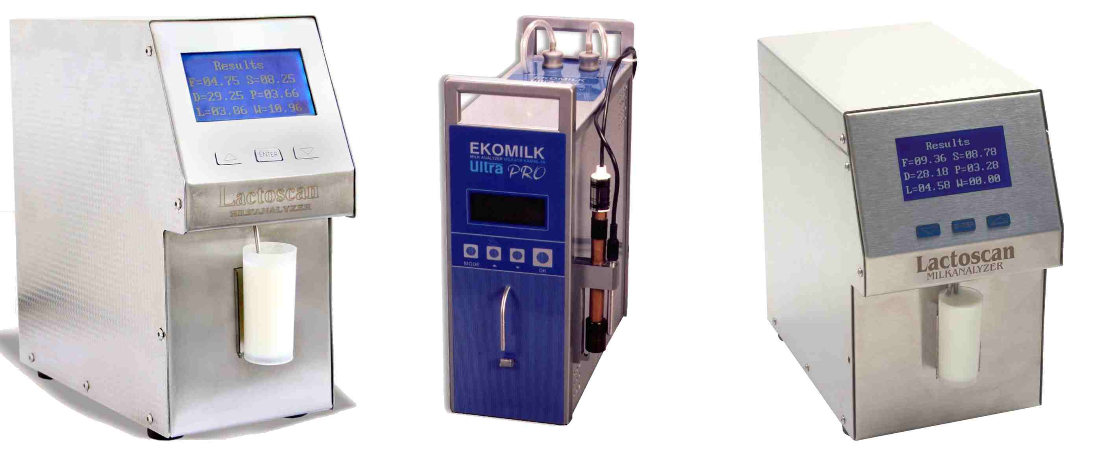

- Detects FAT,SNF,CLR,Lactose,Protein,Salts,Sugar,Added Water, Temperature.
- Dual-Sensor.
- Reports within 25-30secs.
- Works on Battery, Inverter 12VDC.
- Computer & AMC Interfacing RS-2323,U-ART.
- One Year Warranty & 3 Years Performance Guarantee.
- Highest Accuracy, Fast Calibration, Milk Leakage Sensor.
- Measurement repeatability is +/-0.03% Fat, +/-0.05% SNF and +/-0.75% Added Water
- Easy to Clean, Lightweight Design and Compact

Specifications
- FAT: 0.1% TO 25% (+/- 0.1%)
- SNF: 3% to 15% (+/- 0.15%)
- CLR: 20 to 40 (+/-1)
- Lactose: 0.01% to 6% (+/- 0.2%)
- Protein: 2% to 7% (+/- 0.15%)
- Added Water: 0% to 99% (+/- 3%)
- Temperature: 5C to 50C
- Ash: 0.4% to 1.5% (+/- 0.05%)
Add photo & Information of Dyna Milk:

Electronic Weighing Scale
get quote

Dock milk weighing scale
Dock weighing scale, which is totally built in 304-stainless steel having capacity of 600 kg along with accuracy of 100/500/1000gms.With one year Govt. stamping certificate.

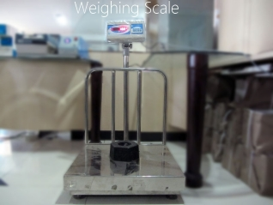
Features
- Capacity:60/150-200/600kg/Lit
- Accuracy:50/100/200/500/1000gms.
- Power Supply: 220-24V AC/12V Dc.
- RS232 Port: Computer Interface.
- Serial Printing Interface.
- Indicator with Remote Display.
- Serial Printing Interface.
- Kg.to Litre. conversion facility.
- Kg. Formula changing facility Available.
- Interface with Microprocessor & PC.
- Fully Protected from Moisture & Humidity.
- S.S. 304 Platform &S.S Load Cell (moisture proof)
Types of Weighing Scales:
1. Plat form /tabletop weighing scale –150Kg, 250 Kg, 300 Kg.
- Electronic weighing scale which are specially meant for dairy industry
- Moisture & humidity proof,
- Sturdy with heavy duty Load
- No. Of scales are being used since from 5 to 6 years without a single complaint.
- Heavy-duty material is used so there is no challenge for its strongness.
- Available in M.S. & stainless steel also.
2. Tank weighing scale:
Used mainly on Dock where large amount of milk is collected.
3. Lab scale
4. Truck weighing Way bridges
get quote
I will give you information of RMRD dock weighing scale.

